1. Technical Abstract Specifications

The abstract must be at least one and no more than two pages long.
If you use a U.S.-standard page (8.5 x 11 in./21.59 x 27.94 cm), set margins to .875 in. (2.22 cm) left and right, 1.0 in. (2.54 cm) top and 1.25 in. (3.17 cm) bottom. If you use an A4 page, set margins to 1.925 cm left and right, 2.54 cm top, and 4.94 cm bottom.
Single-space all text in one column, allowing extra space between paragraphs. Use Times Roman or equivalent font for all text. Use boldface or italic for emphasis only. The proper fonts (all Times Roman) for various elements are as described and shown below along with more detail on how to handle elements of your paper.

Article title is 16 pt bold. Center the paper title at the top of the page. Capitalize only the first word, proper nouns, and acronyms. Keep titles brief and descriptive. Avoid starting with articles or prepositions, e.g., "The study of … ," "On the …." Spell out acronyms unless they are widely known. Author Names and Affiliations are 12 pt and centered. Capitalize proper nouns. Leave extra space between authors and affiliations/address. Omit titles or degrees such as Dr., Prof., Ph.D., etc. Avoid acronyms that are not internationally known.
Keyword list is an untitled list of up to 10 keywords of your choice in 10 pt with standard capitalization. Do not put a heading on this list of keywords. Insert it between the abstract title and the body of the paper. This list will ensure that your paper is indexed appropriately.
Section headings are 11 pt bold capital letters throughout the words centered on separate lines. Number sections sequentially (i.e., 1, 2, 3,...). Subsection headings are 10 pt bold with capitalization of the first letter of the first word and proper names only. Type on a separate line flush with the left margin.
Paragraphs
Leave additional space between paragraphs. Indentation is optional. Body text is 10 pt with standard capitalization.

Figures and tables
Figures and tables should be clear and legible but sized to make economical use of space, and must fit entirely within the manuscript image area. Similar or related figures should be of uniform size with uniform lettering. All figures should be called out in the text as well as properly labeled and captioned. Number figures sequentially using Arabic numerals, and place a numbered caption near each figure or table. Figures may be positioned within the text or at the end of the manuscript. Figure and table captions are 9 pt with capitalization of the first letter of the first word and proper nouns only. Begin each caption with figure or table number.
Footnotes
Additional author information, such as email addresses and web site location should be given in a footnote. Footnotes must appear within the page image area. Footnote text is 9 pt with capitalization of the first letter of the first word and proper nouns only.
Acronyms
For the first occurrence (other than for commonly used acronyms such as IR, CCD, MTF, etc.), spell out each word followed by the acronym in parentheses, e.g., liquid phase epitaxy (LPE) or Extreme Ultraviolet Explorer (EUVE).
Equations
Type all equations. Punctuate as a sentence. Type display equation numbers in Arabic numerals in parentheses flush with the right margin. Number display equations consecutively.
References
Denote reference citations within the text of your paper by means of a superscript number. List references at the end of the paper in numerical order, and enclose the reference number in square brackets. Include the following information (as applicable). For a proceedings paper: authors (last name first, then initials), "paper title" (in quotes), proceedings volume name and/or number, page numbers (year).
[3] Van Derlofske, J. F., "Computer modeling of LED light pipe systems for uniform display illumination," Proc. SPIE 4445, 119-129 (2015).

2. Contents of Abstract

Low-cost wireless home automation solution using microcontrollers
Robert-Valentin Ene ¹⁾, Calin Bira ²⁾
¹⁾ POLITEHNICA University of Bucharest, Bucharest, Romania
²⁾ POLITEHNICA University of Bucharest, Bucharest, Romania

Keywords: smart home, automation, IoT, smart things, esp32, web control, device

Summary:

Home automation and the whole idea of smart homes is becoming more and more important and wondered in the 21st century. The main goal of this project is to create and develop a smart system through which we can receive data from different sensors on our phone and control the functionality of our home directly from our smartphone. The technologies used in this project are the wireless communication protocol - Wi-Fi; ESP-NOW which is a wireless transmission protocol created by Espressif between several ESP32 development boards; different serial transmission protocols - uart, i2c, spi; databases for data accumulation and protection; a front-end part where we will have the user interface. The proposed application allows easy control of household utilities: turning on / off light bulbs, turning on / off AC, turning on / off TV. Also, the remote controls for each device are not used because the system is able to learn and reproduce the IR signals from the physical remote control, and to use the buttons on the web application on the phone instead. All this things are implemented in our own network, using the ssid of the Wi-Fi router and the network password to create an intelligent system, without wires and complex physical networks.

Motivation
As the title says, with a smart home life is simple. That is our motivation, to make people’s life better and more enjoyable. Having a smart home gives you security and pleasure every time you get home. The proposed project is to design and implement a system that will monitor specified house data to ensure the house remains secure. It will also be able to control specific functions within the house as well.

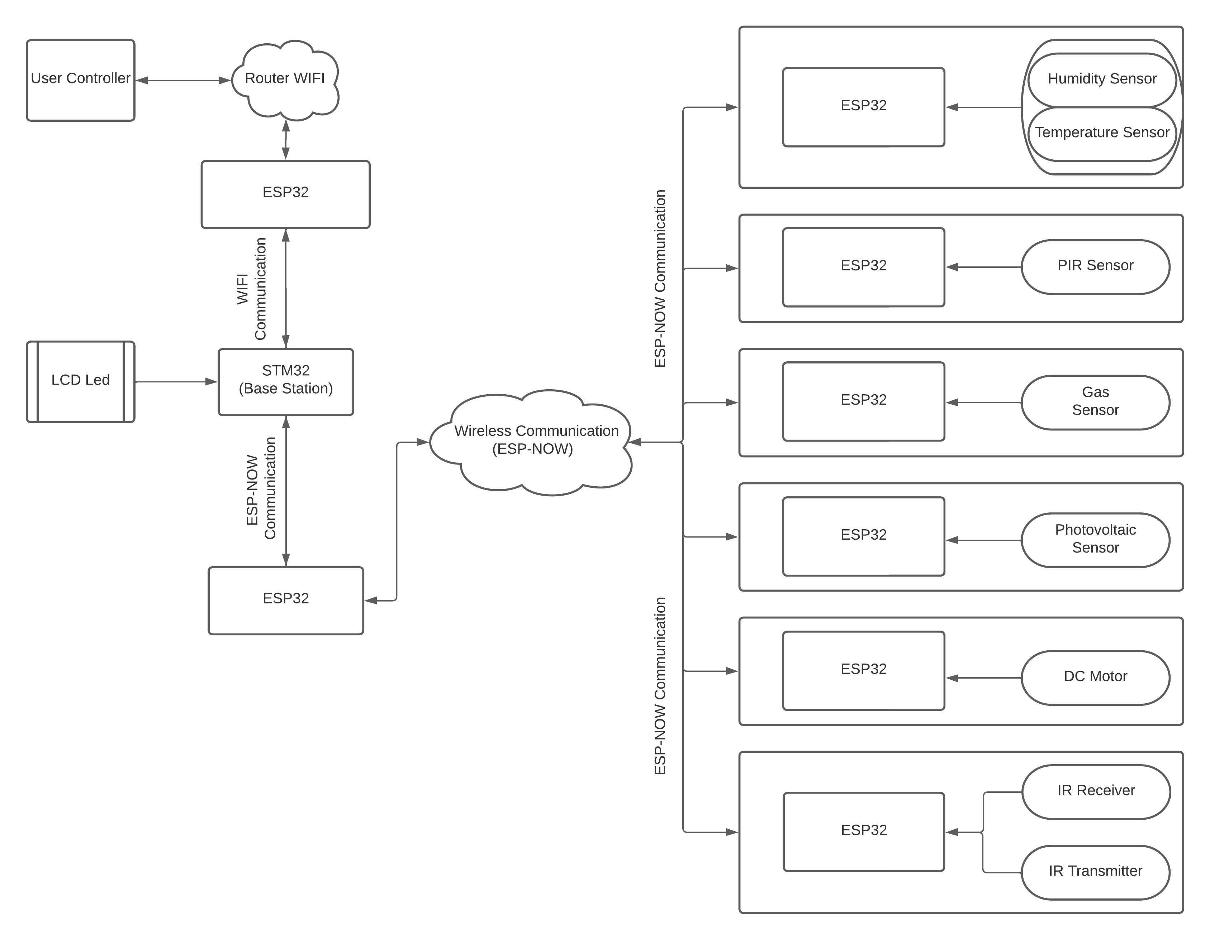
Results

Acknowledgement
I would like to thank my professor Calin Bira for the continuous, moral and financial support in the development of the project and Politehnica University of Bucharest for preparing me over 4 years to be able to finish this project successfully.

References
For a proceedings paper: authors (last name first, then initials), "paper title" (in quotes), proceedings volume name and/or number, page numbers (year).
[3] Van Derlofske, J. F., "Computer modeling of LED light pipe systems for uniform display illumination," Proc. SPIE 4445, 119-129 (2010).

Please indicate as foot notes :
- Postal and Email address of corresponding author
- Number and name of Section
0. Plenary Speaker
1. Advanced materials and new technologies
2. Diffractive, micro optics, and optical signal processing
3. Sensors, microsystems, and instruments
4. Micro/ nanophotonics and micro/ nanotechnologies
5. Modeling, design, and simulation
6. Optics-inspired approaches for non-optical applications: systems, devices, and signal processing
7. Biomedical optoelectronics (special section);
8. Plasma methods and diagnostic used for surface treatments (special section);
9. Organic optoelectronic materials and devices (special section, new!);
10.Propagation, reliability and security issues in wireless and optical communications (special section, new!).

